NON-DISCLOSURE AGREEMENT (MUTUAL)
DATE: {{date}}
PARTIES:
{{company name1}}. whose registered company number is {{company-number1}} and address is {{address}} (Company 1); and
{{company name2}}, whose registered company number is {{number}} and address is {{company-number2}} and address is {{address}} (Company 2).
INTRODUCTION:
The Parties have agreed to disclose certain confidential information to each other for the Purpose (as defined below) on the terms and conditions set out below.
AGREEMENT:
1. Definitions and Interpretation
Associate means any subsidiary or holding company of the Receiving Party, and any other subsidiary of such holding company;
Confidential Information means all information and material (including any copies or other material incorporating all or part of the Confidential Information or referring to the Confidential Information) disclosed directly or indirectly (whether before or after the date of this Agreement) by any and all means, methods and formats by or on behalf of the Disclosing Party to the Receiving Party including any information or material relating to the Disclosing Party's corporate operation, its clients and potential clients wheresoever situated, its existing and future services and product offerings and its projects in development and all associated systems, operations, opportunities, business plans, intentions, market opportunities, know-how, trade secrets, software, intellectual property rights, personnel, research, data, costs, prices, finances, business affairs, and the fact that the Parties are in discussions about the Purpose;
Disclosing Party means the Party which discloses Confidential Information;
Party means either Company 1 or Company 2;
Purpose means the discussions and negotiations between the Parties relating to [Company 1 / Company 2, and/or the Parties products and services, and/or a potential relationship between the Parties]; and
Receiving Party means the Party which receives Confidential Information.
References to Clauses are to clauses in this Agreement. The term including shall be construed as illustrative, without limiting the sense or scope of the words preceding it. The singular includes the plural and vice versa. Headings are inserted for convenience only and do not affect the interpretation of this Agreement.
Receiving Party Obligations
In consideration of the disclosure of the Disclosing Party’s Confidential Information hereunder the Receiving Party agrees:
to use the Confidential Information only in relation to the Purpose;
to keep the Confidential Information at all times confidential and not to disclose the Confidential Information (other than in accordance with Clause 3);
without limitation to the foregoing, to exercise in relation to the Confidential Information, no lesser security measures and degree of care than it applies to its own confidential information;
to make copies or reproductions of the Confidential Information only as is strictly necessary to fulfil the Purpose;
to keep all Confidential Information (including any and all copies, images, documents, computer files or other materials incorporating or referring to any of the Confidential Information) separate from all other documents and materials and in a secure place; and
not reverse-engineer, decompile, or disassemble any software disclosed hereunder.
Disclosure of Confidential Information
The Receiving Party may disclose the Confidential Information to their Associates, employees and/or professional advisers (Permitted Recipients) but only where it is strictly necessary to achieve the Purpose. The Receiving Party undertakes that any Permitted Recipients shall be made aware of the confidentiality obligations and shall comply at all times with the terms herein (or materially similar terms) as if they were the Receiving Party under this Agreement with the same obligations and liability as the Receiving Party (jointly and severally).
Excluded Information
The obligations set out in Clause 2 shall not apply to any Confidential Information that the Receiving Party can demonstrate:
was at the time of this Agreement or has subsequently come into the public domain other than as a result of a breach of this Agreement;
has been lawfully received by the Receiving Party from a third party without restriction on its use or disclosure;
was lawfully and independently developed by the Receiving Party other than as a result of a breach of confidentiality; or
is disclosed in response to an order by a court or other governmental body or regulatory body or as otherwise required by law (provided that the Receiving Party first notifies the Disclosing Party regarding the required disclosure and consults with the Disclosing Party regarding the manner and timing of such disclosure and (if requested) co-operates with the Disclosing Party if it elects to contest such disclosure).
Return of Confidential Information
If either Party elects not to pursue the Purpose, each Party shall promptly (and in any event within five (5) days of receipt of a written request from the other) return to the other the Confidential Information (including for the avoidance of doubt all documents, copies or other materials that incorporate or refer to the Confidential Information), or if specifically requested by the other, destroy the same (or render it permanently inaccessible in the case of information held digitally) and certify to the other in writing that this has been done.
Duration
The obligations undertaken by the Parties under this Agreement will be continuing for a period of five (5) years and, in particular, will survive the termination of the Purpose.
General
Each Party undertakes that it is entitled to enter this Agreement and to perform its obligations herein.
Neither Party makes any warranty, undertaking or representation about the validity, completeness or accuracy of the Confidential Information.
No right or licence is granted by either Party to the other in relation to the Confidential Information except as is strictly required for the fulfilment of the Purpose.
This Agreement does not commit either Party to enter into any proposed venture relating to the Purpose (or otherwise).
No failure or delay on the part of either Party to this Agreement to exercise any right, power, privilege or remedy provided under this Agreement shall operate as a waiver of such right, power, privilege or remedy or as a waiver of any proceeding or succeeding breach by the other Party to this Agreement.
The Parties acknowledge that damages would not be an adequate remedy for a breach of this Agreement and that either Party is entitled to seek the remedy of injunction, specific performance and/or other equitable relief in respect of any threatened or actual breach of this Agreement.
No third party shall have rights under the Contracts (Rights of Third Parties) Act 1999 to rely upon or enforce any term of this Agreement.
This Agreement contains the full and complete understanding between the Parties and supersedes all prior arrangements and understandings whether written or oral relating to the Purpose and may not be varied except by written agreement signed by the Parties.
Neither Party shall, without the prior written consent of the other, assign, transfer, sub-contract, sub-license or otherwise dispose of the benefit or the burden of this Agreement.
This Agreement may be executed in two counterparts each of which when executed and delivered is an original, but the counterparts together shall constitute the same document.
This Agreement shall be governed by and construed in accordance with the laws of England and Wales and the Parties submit to the jurisdiction of the High Court of England and Wales as regards any claim, dispute or other matter arising under or in relation to this Agreement.
AS WITNESS that the Parties have entered into this Agreement on the date appearing at the head of this Agreement.
SIGNED by Print name: {{name1}}

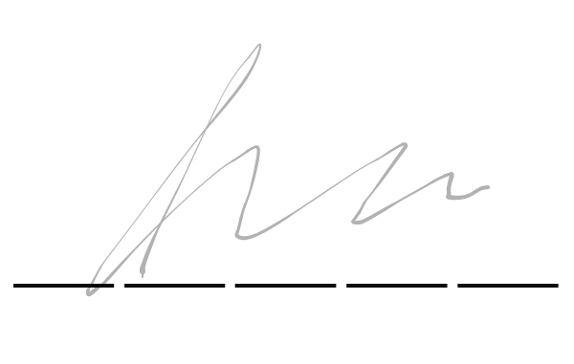

a duly authorised signatory of Title: {{title1}} {{company name1}}.
Signature
SIGNED by Print name {{name2}}
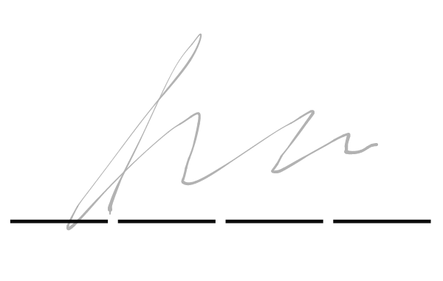
a duly authorised signatory of Title {{title2}} {{company name2}}
Signature

